# **User Requirements Specifications**

**China Express**

Boyan Apostolov

Date: 16.04.2024

Student: Boyan Apostolov

St.Number: 5030781

Version: 2.0

**Purpose of the document**

The purpose of the document is to outline the functional and non-functional requirements of the China Express application. It provides a structured view of the features and capabilities that the system must possess to meet user needs and expectations.

**Contents of the document**

|  |  |  |
| --- | --- | --- |
|  | Functional Requirements |  |
| FR ID | **Name** | **Possibility** |
| FR-01 | Adding Users | M |
| FR-02 | Updating Users’ Data | M |
| FR-03 | Adding Categories | M |
| FR-04 | Adding Single Product | M |
| FR-05 | Editing Single Product/Combo Boxes | М |
| FR-06 | Deleting Single Product | М |
| FR-07 | Adding Combo Boxes | М |
| FR-08 | Deleting combo boxes | M |
| FR-09 | Changing order Status | M |
| FR-10 | Creating an Order | M |
| FR-11 | Adding Review for a Product | M |

|  |  |  |
| --- | --- | --- |
|  | Non-Functional Requirements |  |
| NFR ID | **Name** | **Priority** |
| NFR-01 | Response Time/ Performance | M |
| NFR-02 | Security | H |
| NFR-03 | Ease of Use | H |
| NFR-04 | Error Handling | M |

|  |  |
| --- | --- |
| Use case ID | UC-01 |
| FR ID | FR-01 |
| Use case Name | Adding Users |
| Actor(s) | Employee |
| Preconditions | The actor is logged in the system |
| Main Success Scenario | 1. The actor navigates to the Users Page 2. The actor requests the Add User Page 3. The systems shows New User page 4. The actor fills the required information 5. The actor requests the system to save the information 6. The system redirects the actor to the Users page |
| Extensions | 4a. One or more of the data fields is not in the correct format   1. The system displays an error message 2. Return to MSS Step 3   5a. The user already exists in the system (by email)   1. The system displays the appropriate error message 2. Return to MSS Step 3 |
| Postconditions | 1. A new User profile is successfully created and stored in the system. 2. The actor can view and manage the newly created employee profile. |
| Application | Desktop |

|  |  |
| --- | --- |
| Use case ID | UC-02 |
| FR ID | FR-02 |
| Use case Name | Updating Users’ Data |
| Actor(s) | Employee |
| Preconditions | The actor is logged in the system |
| Main Success Scenario | 1.The actor navigates to the Users Page  2. The actor requests to edit the corresponding user  3. The system shows the Edit User  4. The actor fills the required information  5. The actor requests for the system to save the updated data  6. The system redirects the actor to the Users page |
| Extensions | 4a. One or more of the data fields is not in the correct format   1. The system displays an error message 2. Return to MSS Step 3   5a. The user already exists in the system (by email)   1. The system displays the appropriate error message 2. Return to MSS Step 3 |
| Postconditions | 1. The User profile is successfully saved in the system. |
| Application | Desktop |

|  |  |
| --- | --- |
| Use case ID | UC-03 |
| FR ID | FR-03 |
| Use case Name | Adding Categories |
| Actor(s) | Employee |
| Preconditions | The actor is logged in the system |
| Main Success Scenario | 1. The actor navigates to the Categories Page  2. The system display the Categories page  3. The actor inserts the desired category name into the box  4. The Actor requests the system to save the data  5. The system redirects the actor to the Categories Page |
| Extensions | 3a. The input field is empty   1. The system displays an error message 2. Return to MSS Step 1 |
| Postconditions | 1. The system saves the new category |
| Application | Desktop |

|  |  |
| --- | --- |
| Use case ID | UC-04 |
| FR ID | FR-04 |
| Use case Name | Adding Single Product |
| Actor(s) | Employee |
| Preconditions | The actor is logged in the system |
| Main Success Scenario | 1.The actor navigates to the Products Page  2. The actor requests the Add product Page  3. The New Product page is shown by the system  4. The actor fills the required information  5. The Actor requests the system to save the data  6. The system redirects the actor to the Products Page |
| Extensions | 4a. One or more of the data fields is not in the correct format   1. The system displays an error message 2. Return to MSS Step 3 |
| Postconditions | 1. The new product is successfully saved in the system. |
| Application | Desktop |

|  |  |
| --- | --- |
| Use case ID | UC-05 |
| FR ID | FR-05 |
| Use case Name | Editing Single Product/Combo Boxes |
| Actor(s) | Employee |
| Preconditions | The actor is logged in the system |
| Main Success Scenario | 1.The actor navigates to the Products Page  2. The actor requests to edit the corresponding item  3. The Edit Product page is shown by the system  4. The actor fills the required information  5. The Actor requests the system to save the data  6. The system redirects the actor to the Products Page |
| Extensions | 4a. One or more of the data fields is not in the correct format  1. The system displays an error message  2. Return to MSS Step 3 |
| Postconditions | 1. The edited product is successfully saved in the system. |
| Application | Desktop |

|  |  |
| --- | --- |
| Use case ID | UC-06 |
| FR ID | FR-06 |
| Use case Name | Deleting Single Product |
| Actor(s) | Employee |
| Preconditions | The actor is logged in the system |
| Main Success Scenario | 1. The actor navigates to the Products Page  2. The system display all products  3. The actor requests to delete the corresponding item  4. A confirmation box is shown  5. The system checks if the Products is part of a Combo Box  6. The system removes the Product  7. The system reloads the products |
| Extensions | 5a. The actor chooses “No” in the confirmation box  1. The process is canceled  2. End of case  5b. The Product is part of a Combo Box   1. An Error is shown notifying that the Product cannot be removed 2. End of case |
| Postconditions | 1. The product is removed from the system. |
| Application | Desktop |

|  |  |
| --- | --- |
| Use case ID | UC-07 |
| FR ID | FR-07 |
| Use case Name | Adding Combo Boxes |
| Actor(s) | Employee |
| Preconditions | The actor is logged in the system |
| Main Success Scenario | 1. The actor navigates to the Products Page  2. The actor selects the desired products  4. The Add Combo Box page is shown by the system  5. The actor fills the required information  6 The Actor requests the system to save the data  7. The system redirects the actor to the Products Page |
| Extensions | 5a. One or more of the data fields is not in the correct format  1. The system displays an error message  2. Return to MSS Step 4 |
| Postconditions | 1. The Combo Box is added to the system |
| Application | Desktop |

|  |  |
| --- | --- |
| Use case ID | UC-08 |
| FR ID | FR-08 |
| Use case Name | Deleting Combo Box |
| Actor(s) | Employee |
| Preconditions | The actor is logged in the system |
| Main Success Scenario | 1. The actor navigates to the Products Page  2. The system shows all products  4. The requests to delete the corresponding Combo Box  5. A confirmation box is shown  6. The system removes the Product  7. The system reloads the products |
| Extensions | 5a. The actor chooses “No” in the confirmation box  1. The process is canceled  2. End of case |
| Postconditions | 1. The product is removed from the system. |
| Application | Desktop |

|  |  |
| --- | --- |
| Use case ID | UC-09 |
| FR ID | FR-09 |
| Use case Name | Changing order status |
| Actor(s) | Employee |
| Preconditions | The actor is logged in the system |
| Main Success Scenario | 1. The actor navigates to the Orders Page  2. The actor requests information for the corresponding order  3. The actor choses the necessary status  4. The Actor requests the system to save the data  5. The system redirects the actor to the Orders Page |
| Extensions |  |
| Postconditions | 1. The system saves the new status of the order. |
| Application | Desktop |

|  |  |
| --- | --- |
| Use case ID | UC-10 |
| FR ID | FR-10 |
| Use case Name | Creating an order |
| Actor(s) | Client |
| Preconditions | The actor is logged in the system |
| Main Success Scenario | 1. The actor navigates to the Products Page  2. The system display all products  3. The actor selects the wanted Products with their quantity  4. The actor navigates to the Cart Page  5. The actor inputs his delivery information  6. The actor requests the system to order the items  7. The actor is redirected to his orders |
| Extensions | 5a. One or more of the data fields is not in the correct format  1. The system displays an error message  2. Return to MSS Step 3 |
| Postconditions | 1. The order is places and saved in the system. |
| Application | Website |

|  |  |
| --- | --- |
| Use case ID | UC-11 |
| FR ID | FR-11 |
| Use case Name | Adding Review for a Product |
| Actor(s) | Client |
| Preconditions | 1. The actor is logged in the system 2. The actor has previous orders |
| Main Success Scenario | 1. The actor navigates to the “My Orders” page  2. The system display all previous orders  3. The actor selects an order  4. The system Redirects the actor to the info page of the order  5. The actor requests to reveiw the corresponding product of the Order  6. The system requests information about the review  7. The actor requests the system to save the review  8. The actor is redirected to the “My orders” page |
| Extensions | 56. One or more of the data fields is not in the correct format  1. The system displays an error message  2. Return to MSS Step 5 |
| Postconditions | 1. The review saved in the system. |
| Application | Website |

**Desktop App Product Management Page**The page shows all products in the platform. It allows the employees to initiate creating new products or to merge existing products into an existing ComboBox. It also allows the employees to start editing or to delete products.   
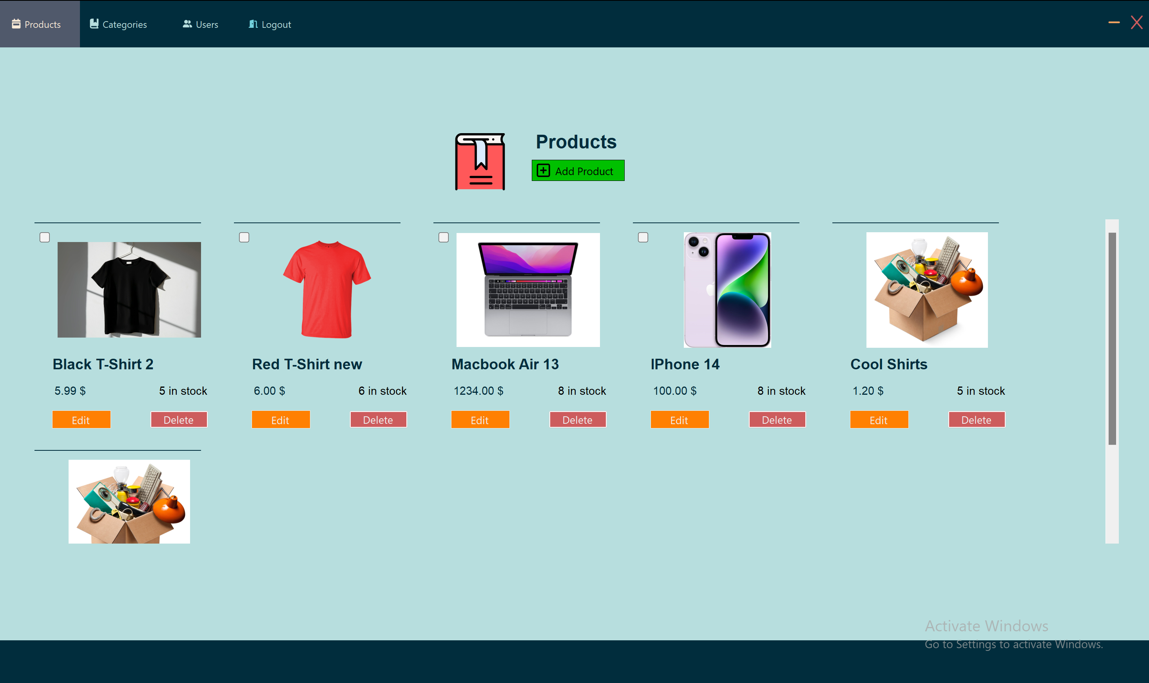

**Web App Home Page**The page welcomes the users in the platform. It shows four randomly picked items to recommend to the users  
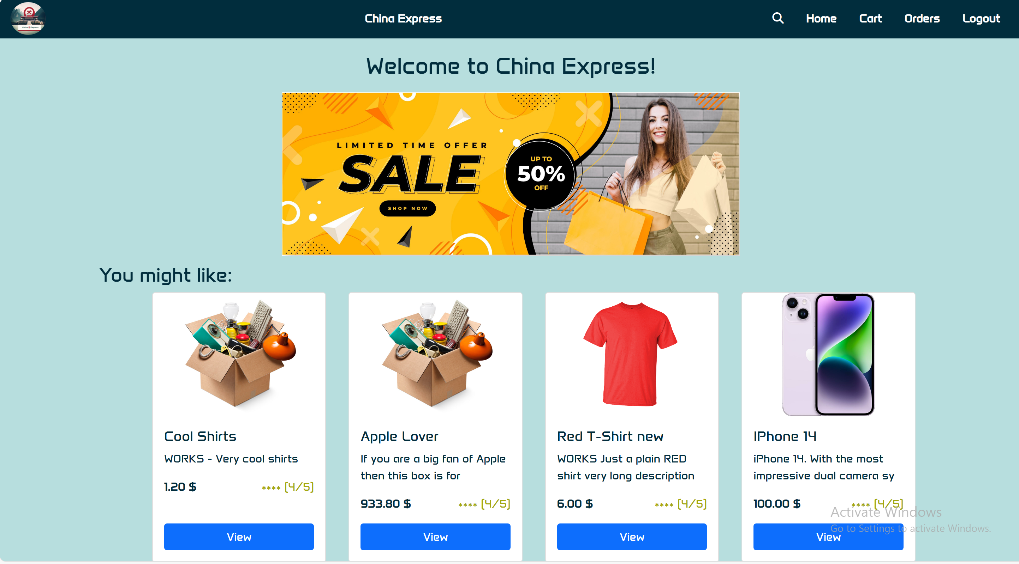

**Web App Cart Page**The cart page allows the users to manage the items that they want to buy by changing their quantity and finalizing the order   
